Methods
Tree growth and mortality rates monitoring
Fourty seven (47) sampling plots have been monitored since 1999 mainly in the former SWGR section to the eastern side. The merging of SWGR and ranching sections expanded the range for rhino and other wildlife but the western sector remained largely unmonitored. The 45 new plots established in 2022 and 2023 aimed to remove this bias making a total of 92 plots (6 excluded and 86 non-excluded) (Fig 1).

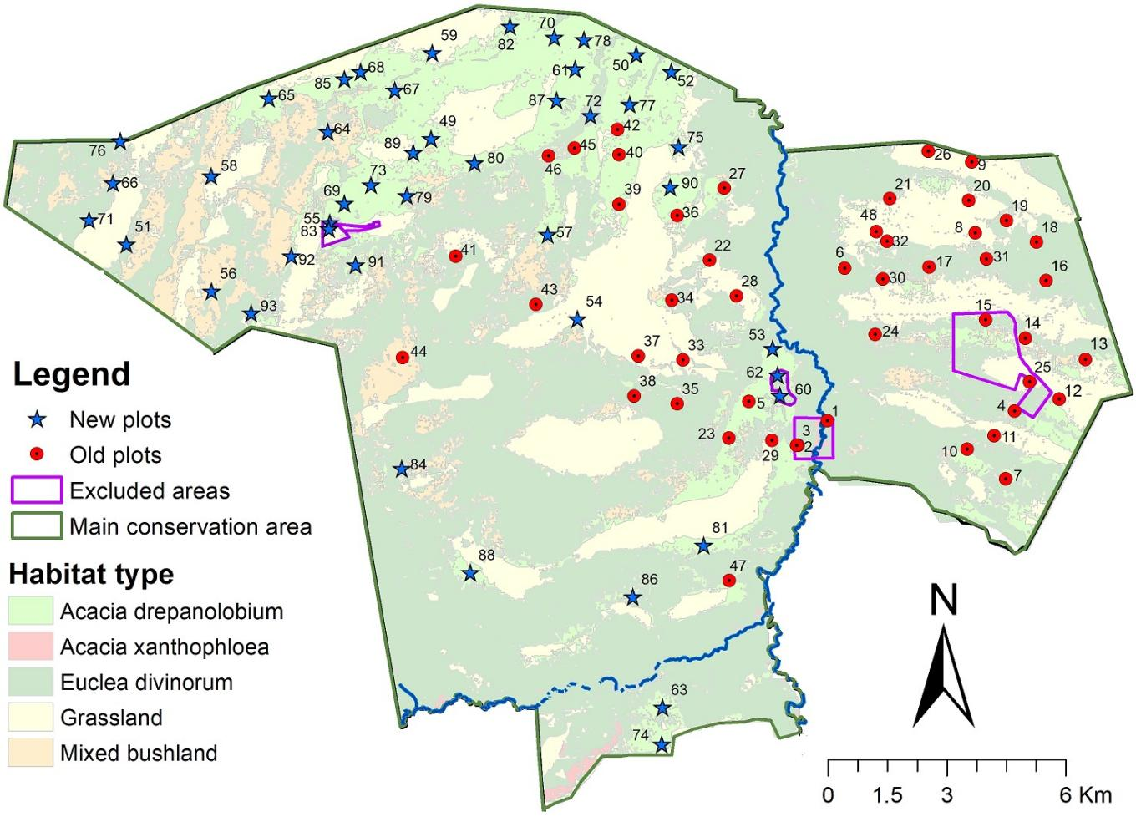
Figure 1: Location of identified (new) sampling plots alongside existing monitoring plots.
Each plot was monitored by locating each of the 50 V. drepanolobium tagged trees and their status recorded (surviving, dead or missing). For consistency and ease of identifying the tagged trees, the GPS coordinates of the first tree in each plot has been saved as the location of the plot. Using a GPS, the project research teams navigated to the first tree and then used the recorded bearing and distance to navigate to the rest of the tagged trees in the plot. In establishing the plots we tried to have a representation of all the height classes height class (0-0.5m, 0.5-1m, 1-2m, 2-3m and above 3m). The previous year’s status of each tagged tree was provided to every consecutive team for ease of identification. Where a tree existed in the previous measurement and it was still surviving, its height was measured using a measuring rod and damage status examined; in cases where a tree was existing previously but was not found dead or missing the following steps were taken to ensure informed decision on its survival status. First the team relocated its position by back bearing to the previous tagged tree; if the bearing and distance were accurate, then they searched for either a dead stump, log on the ground or seedling regrowth from the spot, if any of these were found, an evidence of the aluminum tag, a nail or a wire was then sought. If evidence was found then it was declared dead, missing or regrowth and the new growing tree retagged. For herbivore damage assessment, where a branch or the main stem appeared to have been ripped off, the damage was attributed to elephants, whereas a secateurs type of cut was identified as rhino damage. Selective removal of the soft twigs at the crown of tall V. drepanolobium trees was attributed to giraffe browsing and that on short V. drepanolobium trees was attributed to other browsers like Impalas. Where the V. drepanolobium trees were seen to be drying from the top, this was attributed to natural damage either because of prolonged droughts, age, disease or nutrients deficiency (Fig 2.
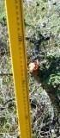
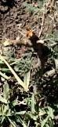
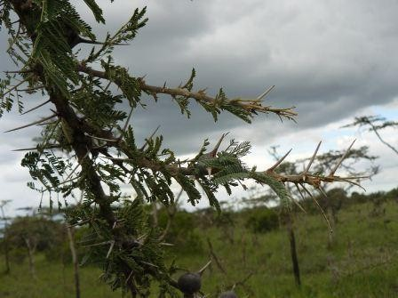
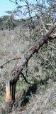
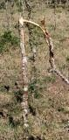
Rhino Damage Secateurs like clean
Giraffe Damage: Tips snapped off
Elephant Damage: Main stem
Figure 2: Physical attributes associated with damage by the three different megaherbivores
Seedling density monitoring
For seedling density monitoring, the first tree in the plot marked the starting point in setting out the 20*20m quadrat. The quadrat was marked by laying out a 20m transect to the east and one to the south of the first tagged. The quadrat was sub-divided into one hundred (100) 2*2m sub-quadrats within which the heights, lengths and diameters all V. drepanolobium seedlings and trees were measured and filled into a datasheet (Fig. 3). The damage status and ant species present were also recorded. The sub-quadrats were necessary to intensify search for seedlings within the quadrat. Seedlings were defined as individuals below 50cm in height consisting of a mixture of trees reversed to seedling stage through herbivore damage and saplings that had not yet recruited into trees. Tree density was computed per height class (0-0.5m, 0.5-1m, 1-2m, 2-3m and above 3m) as the number of trees/seedlings per hectare. The densities were compared between 2023 and 2025.

Figure 3: A layout of the tree/seedling density assessment quadrat
Notes for the excel sheet data
Excluded- means control plots with no elephants, rhinos or giraffes to cause damage
Non-excluded- means the rest of the conservation area where the wild animals are free to roam
Damagers- wildlife feeding on the trees especially rhino, elephant, giraffe, drought and others
In V. drep ants interaction, we are only interested with Crematogaster ants (BBR, RRB, TP and AB-all black) because they have a mutual relationship (shown in the figure below)
Seedling density monitoring captures all the different height classes not only what may be considered as a seedling.
Results expectations
Data tagged trees
- What were the growth and mortality rates in 2023; 2025?
- No of trees alive, missing or dead in the two monitoring periods?
- What was the average change in height? Was the change significant?
- Representation of the different height classes?
- What is the influence of rainfall on growth rate and mortality rate?
- How do growth and mortality rates compare in excluded and non-excluded zones? Mean growth and mortality rates?
- Who were the major damagers?
- What height classes were affected and by which damagers?
- Any relationship between damager and damage height
- How does damage vary between the two years
Data- density
- Average density in 2023;2025? What was the change? Was it significant?
- Average length; average height? How does height relate to length?
- In what height classes do we have height and length varying?
- Vachellia drepanolobium ant interaction
- what is the occupancy of crematogaster ants on V. drep in 2023; 2025?
- What is the relationship between ants presence and damage level?
- What is the relationship between ant species and damager?
